Number 1 Problem: Ping Station
To start off we have this interface:
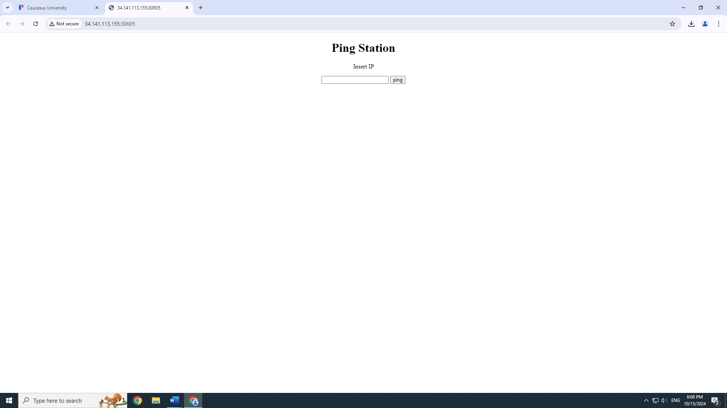
Our input has a vulnerability, which we see through testing many options so basically we can play in the input with many commands as long as they start with a valid IP address.
The following is what will happen if we input something that isn’t acceptable for our system. E.g I tried putting hello and this is our output:
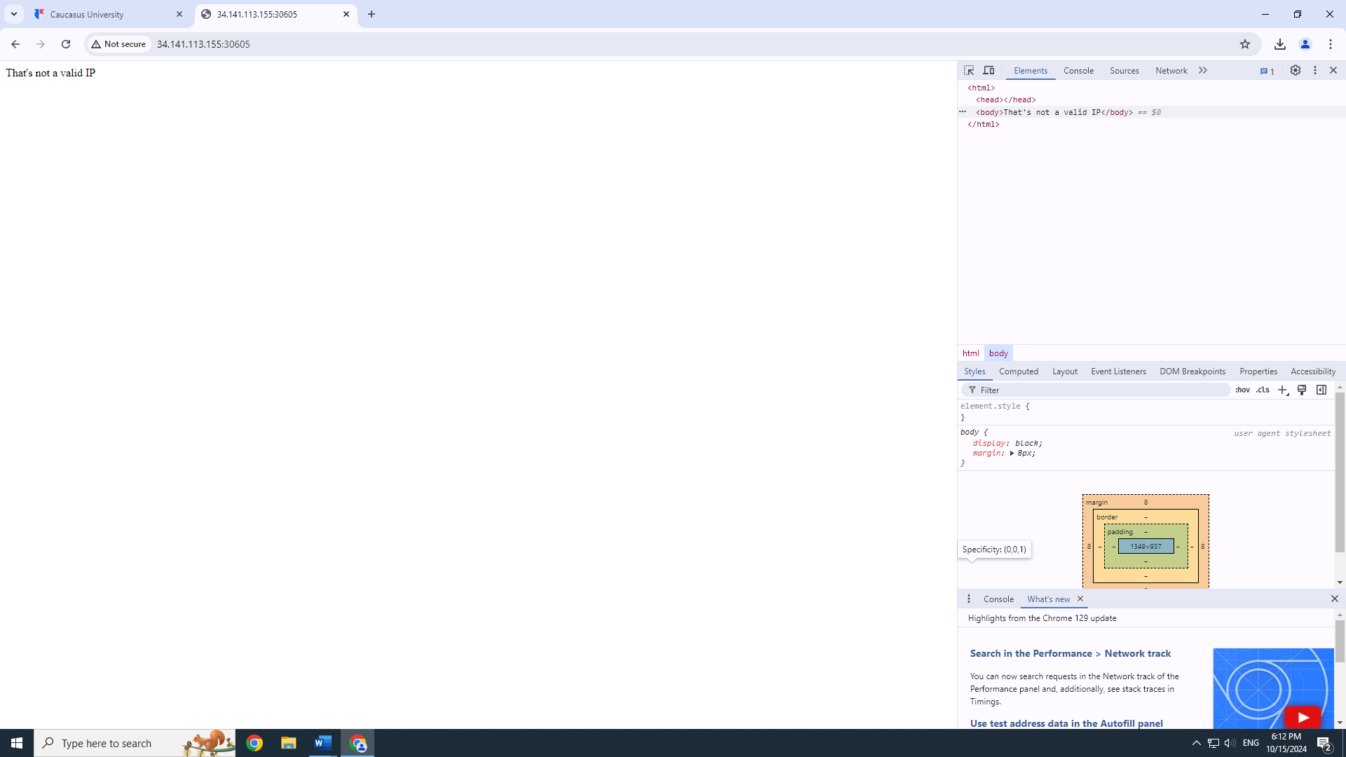
Now I will input a valid IP address, such as 1.1.1.1 (we can change 1.1.1.1 for any other valid IP address).
We can test this vulnerability by entering ’1.1.1.1; ls’ for example and see the contents of the current directory.
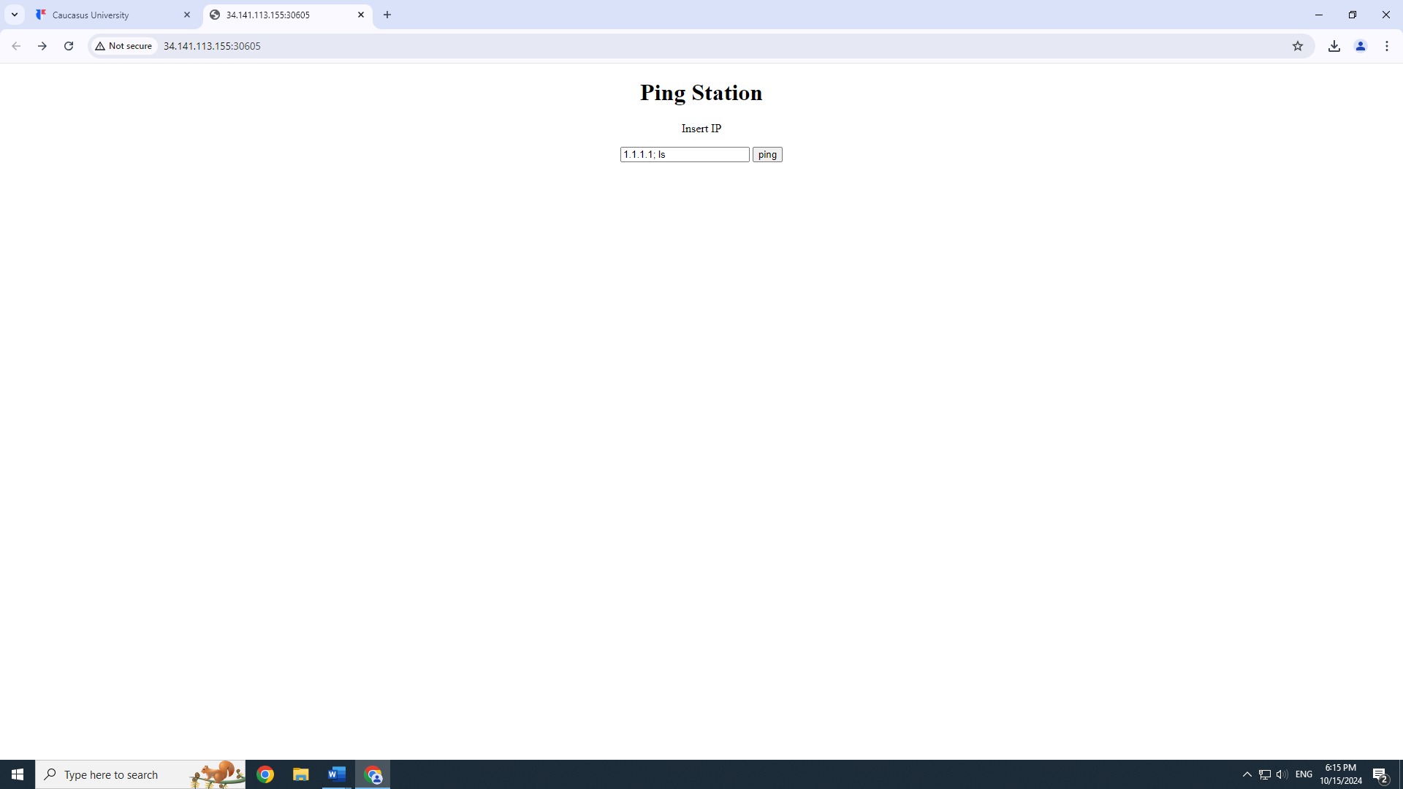
Through this we learn that in the current directory there is a file named ‘flag’ which we output to the page using ‘cat flag’ command.
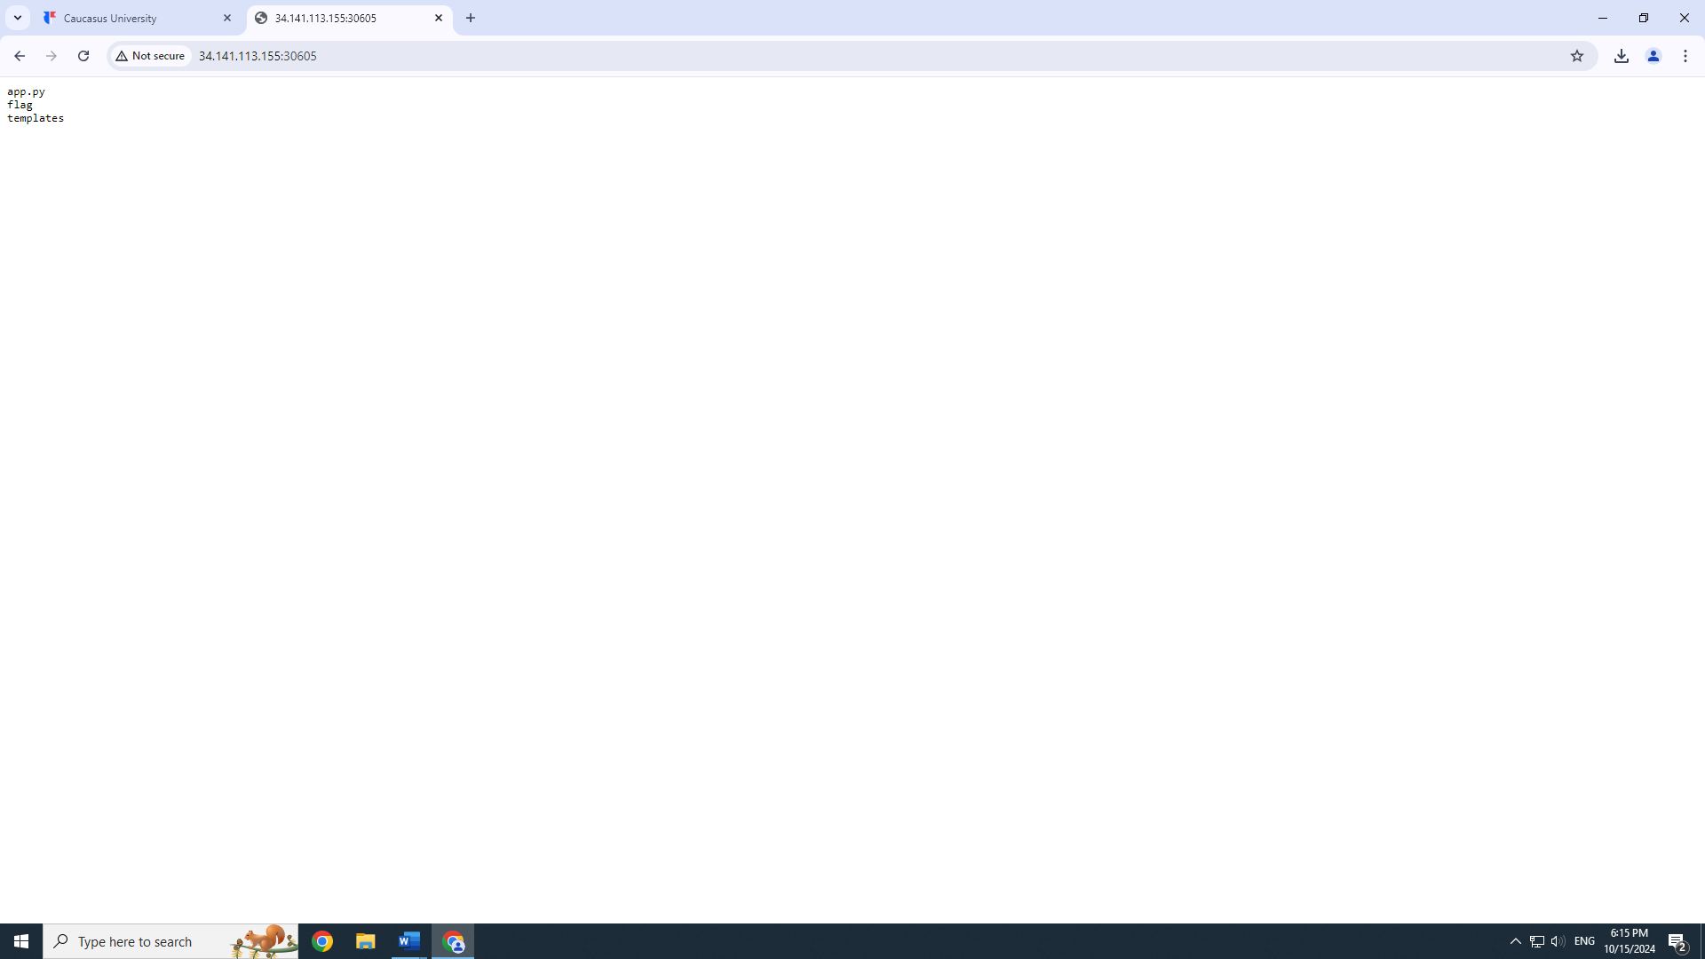
So if we input 1.1.1.1; cat flag in the insert IP space
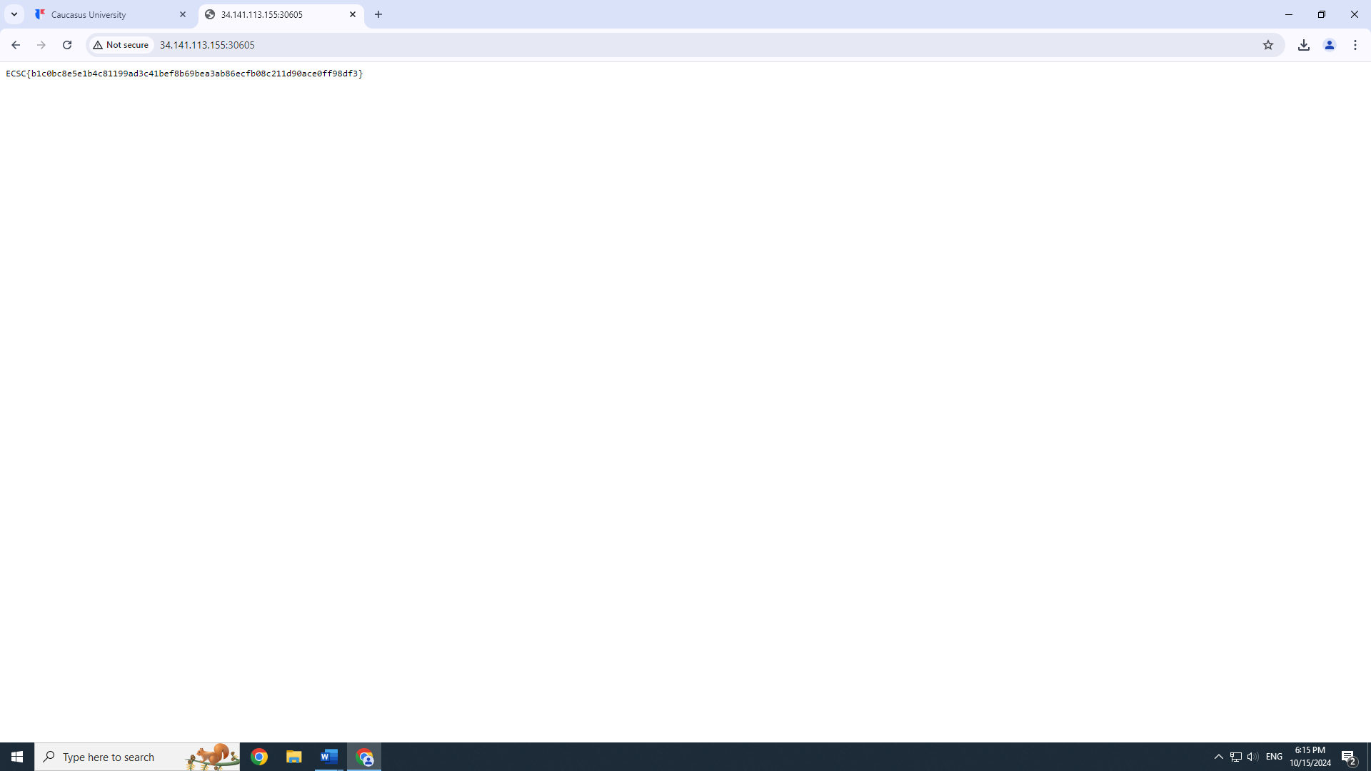
We get our flag: ECSC{b1c0bc8e5e1b4c81199ad3c41bef8b69bea3ab86ecfb08c211d90ace0ff98df3}

Number 2 Problem: Alien-inclusion
Next we have this interface
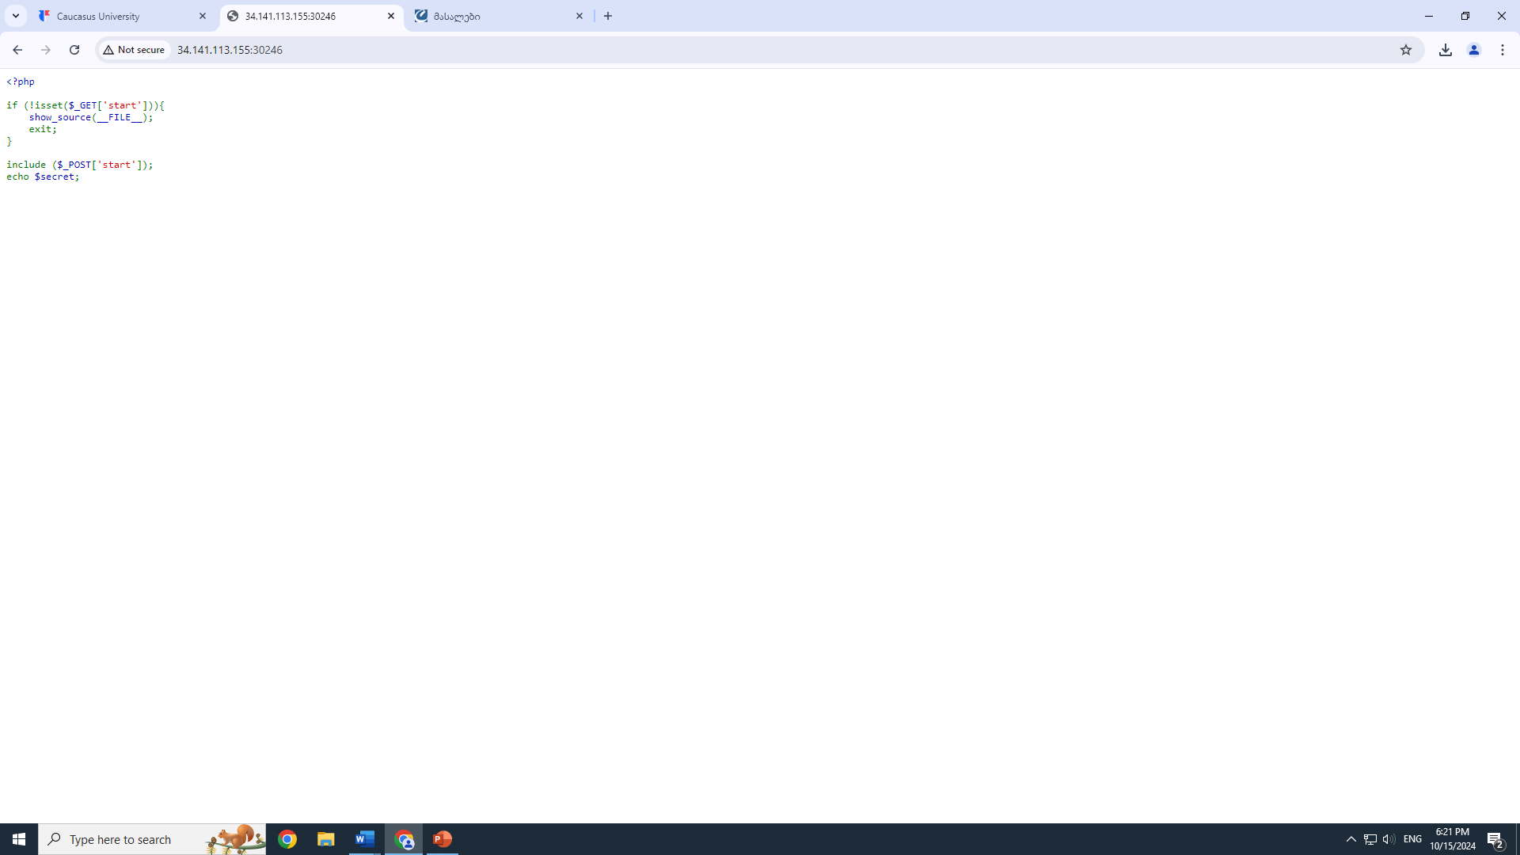
We see that on the landing page we should get ‘start’ parameter in a request. So I am going to use curl in VMWare Kali Linux command to send a post request and I have to set the ‘start’ to the file we want to see and include it in the url. We can also see by using the inspect tool on our interface, that page uses php.
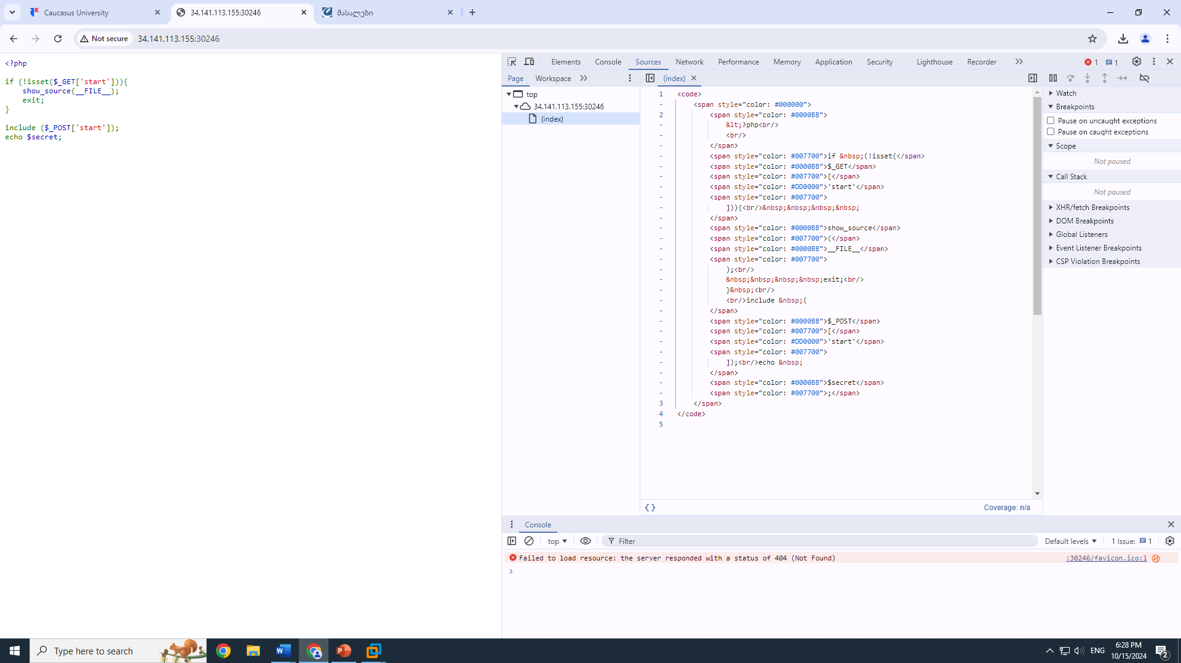
Step by step:
Taking all the abovementioned:
I opened command prompt on Linux VMWare and went with the command curl 'http://34.141.113.155:30246/?start=' --data 'start=flag.php' to find my flag.
Or even the command curl -X POST "http://34.141.113.155:30246/?start=" --data "start=/var/www/html/flag.php" should send a POST request to a web server.
Both aims to include and execute the flag.php file on the server by setting the start parameter to its path. This is used to retrieve the hidden flag for the CTF challenge.
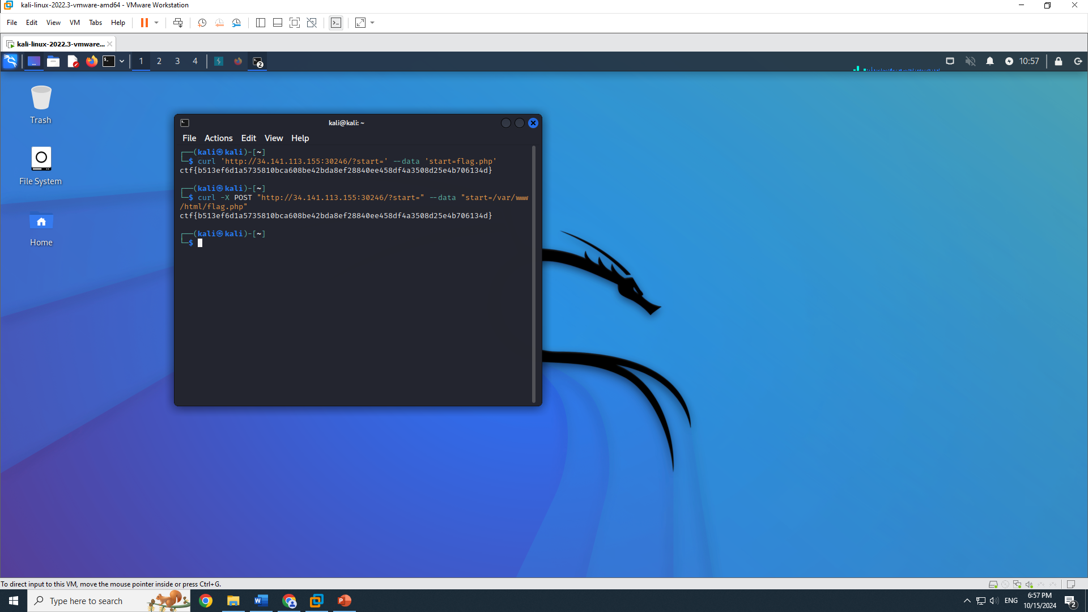
And as expected the command gave us the flag: ctf{b513ef6d1a5735810bca608be42bda8ef28840ee458df4a3508d25e4b706134d}

Number 3 Problem: Ultra-Crawl
Starting off we have this interface: 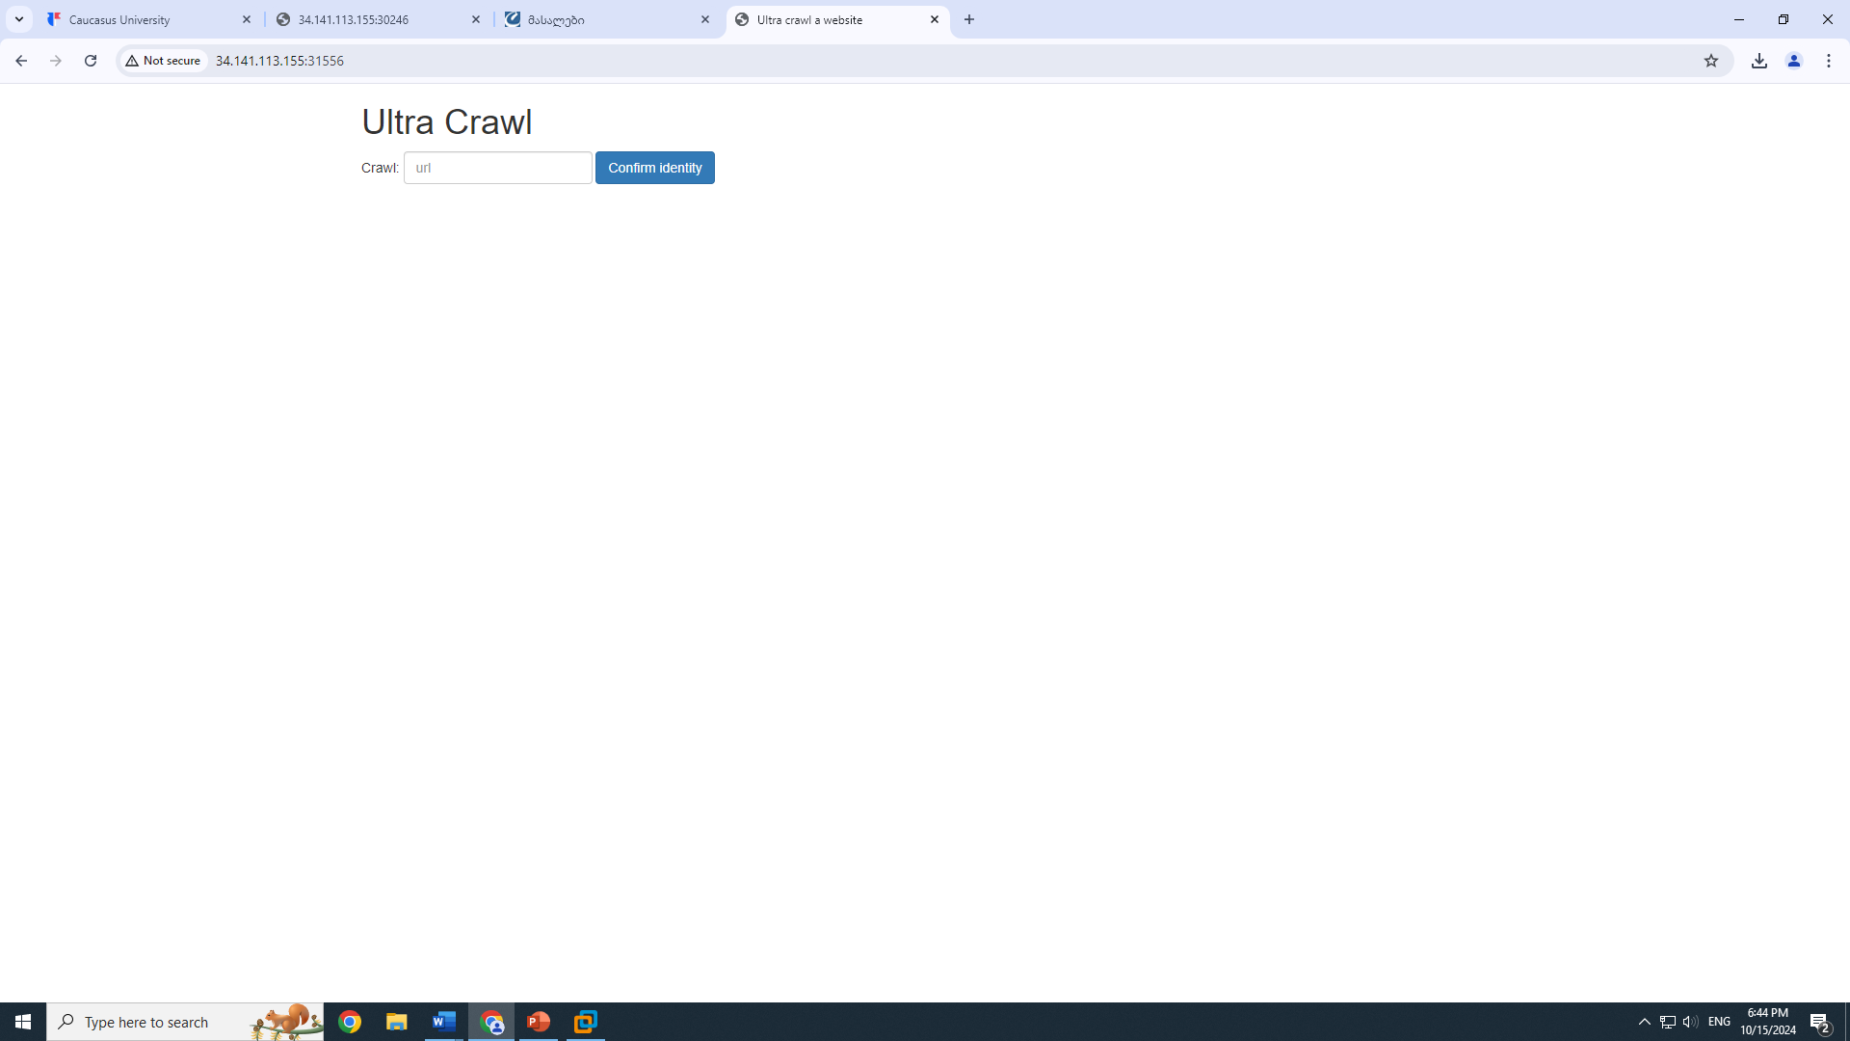
Through testing we can access different files with the input for example: file:///etc/passwd
We can see that there is a home/ctf directory. And probably startup bash script named ‘start.sh’
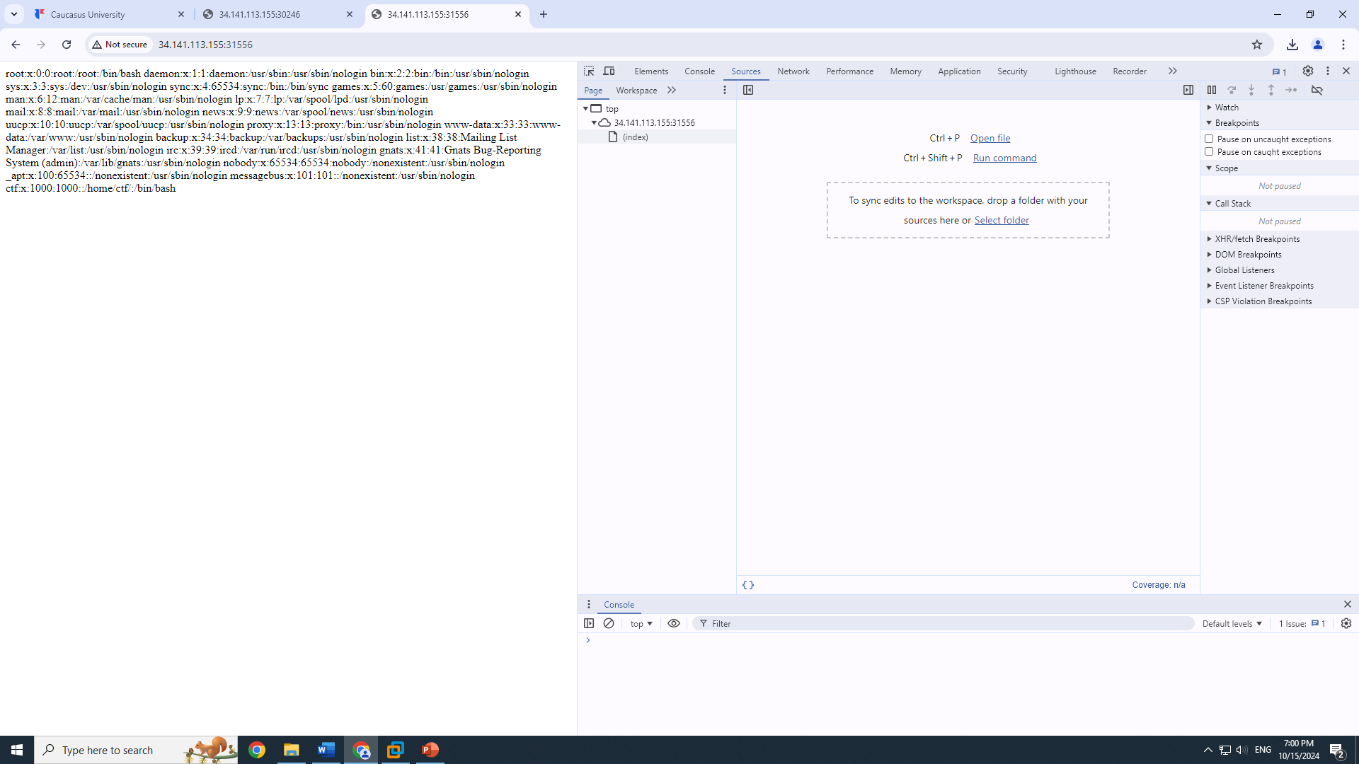
After analysis we know what parameters need to be set in POST request to get the flag and we can now go to BurpSuite and send the request– and set the Host to ‘company.tld’
So, my burpsuite wasn’t working during the midterm and I couldn’t send a request at all.
But if I could this is what I would’ve done: First – I would turn on intercept: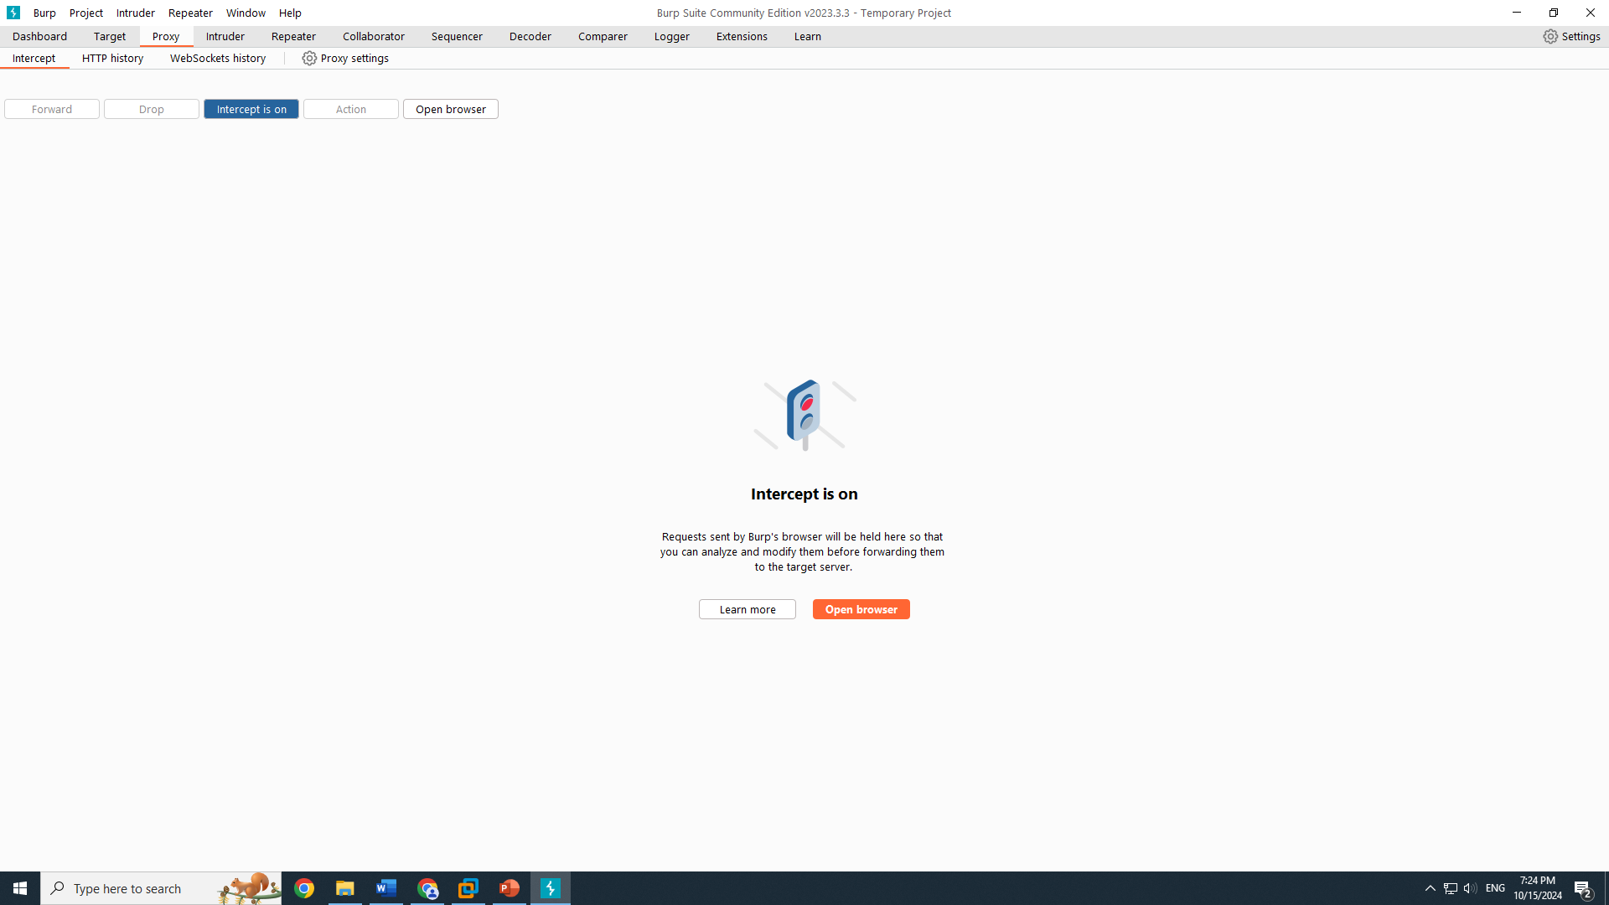
Then I would go to the provided url and send the request to repeater like this:
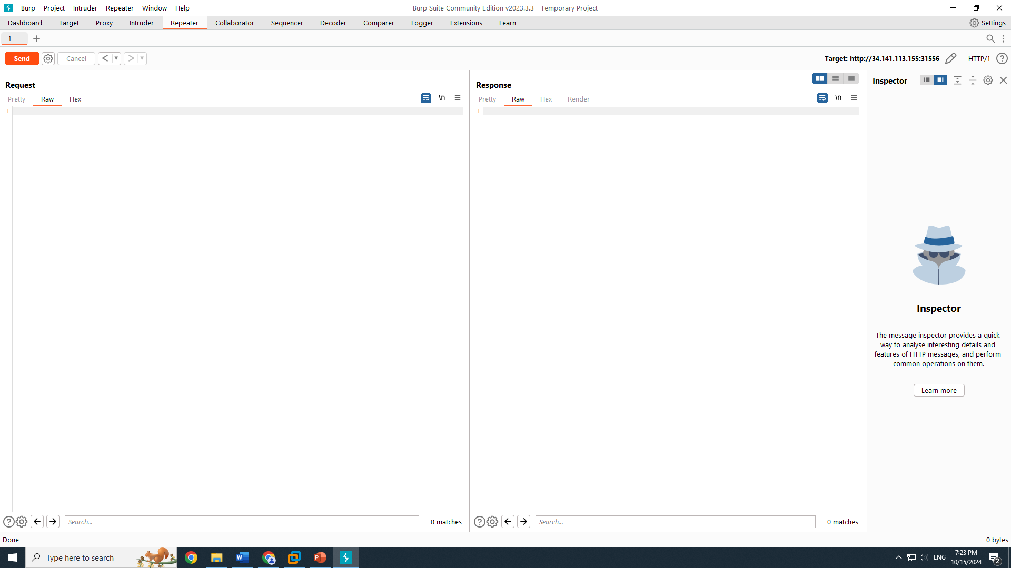
And it would show me the HTTP request details in the new tab and I would change the Host to ‘company.tld ’ and add line ‘ url=file:///home/ctf/app.py ’. (or ‘url=file:////home/ctf/app.py’ with 4 slashes) and then send the modified request. In the response I would see the flag. But this computer and the other ones don’t want to cooperate so I don’t know what else to do about it.
Thank you. That’s all.

